ASSIGNMENT – 9
Q.1 Write a query that lists each order number followed by the name of the customer who made the order.
Ans.
select ORDERS.ONUM, CUSTOMERS.CNAME FROM CUSTOMERS,ORDERS WHERE CUSTOMERS.CNUM = ORDERS.CNUM;
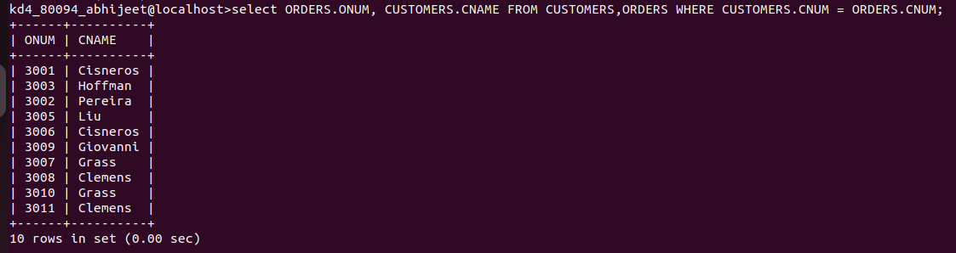

Q.2 Write a query that gives the names of both the salesperson and the customer for each order along with the order number.
Ans. SELECT SALESPEOPLE.SNAME, CUSTOMERS.CNAME FROM ORDERS, CUSTOMERS, SALESPEOPLE WHERE ORDERS.SNUM = SALESPEOPLE.SNU
M AND ORDERS.CNUM = CUSTOMERS.CNUM;

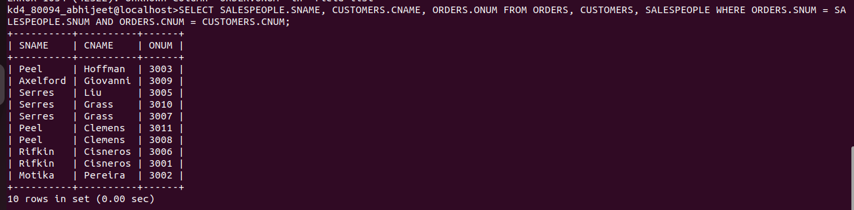

Q.3 Write a query that produces all customers serviced by salespeople with a commission above 12%. Output the customer’s name, the salesperson’s name, and the salesperson’s rate of commission.
Ans.
SELECT CUSTOMERS.CNAME, SALESPEOPLE.SNAME, SALESPEOPLE.COMM FROM CUSTOMERS, SALESPEOPLE WHERE CUSTOMERS.SNUM = SA
LESPEOPLE.SNUM AND COMM> .12;

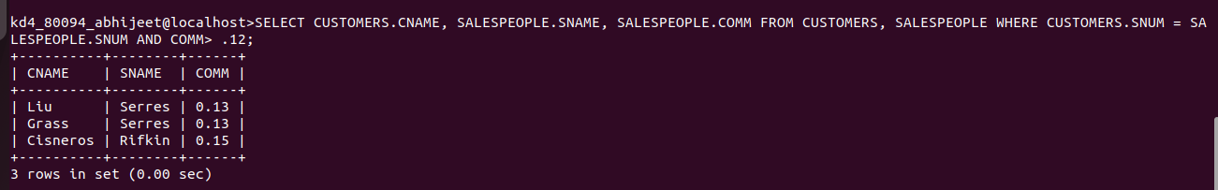

Q.4 Write a query that calculates the amount of the salesperson’s commission on each order by a customer with a rating above 100.
Ans. SELECT ONUM, AMT*COMM FROM ORDERS, CUSTOMERS, SALESPEOPLE WHERE SALESPEOPLE.SNUM = CUSTOMERS.SNUM AND ORDERS.CNUM= CUSTOMERS.CNUM AND RATING>100;

